1. Grade Checker

Take a score as input and print the grade based on the following:

90+ : "A"

80-89 : "B"

70-79 : "C"

60-69 : "D"

Below 60 : "F"

here we used a basic if else statement to carry out marks and all.

Ans: 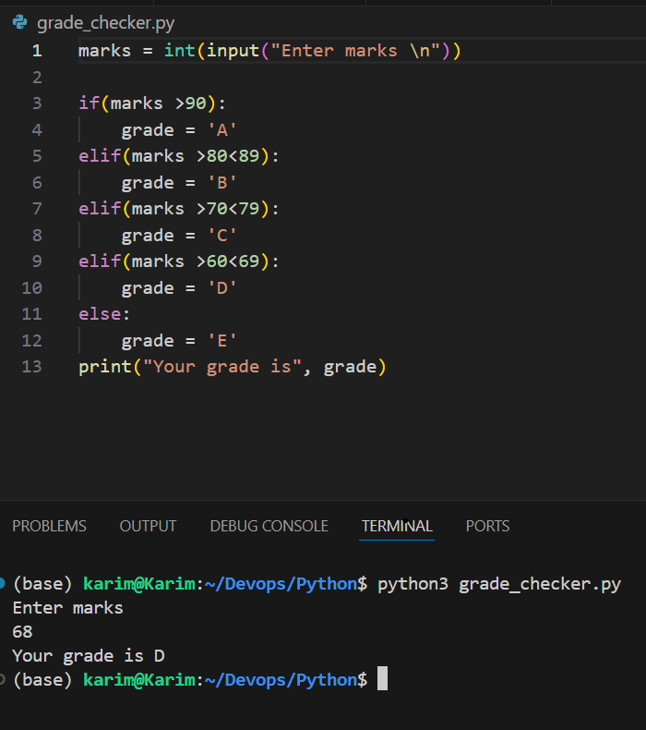

2 Student Grades

Create a dictionary where the keys are student names and the values are their grades. Allow the user to:

Add a new student and grade.

Update an existing student’s grade.

Print all student grades.

Used dictionary and basic operations. Using if else:

Ans: student_grades = {}

def add_student():

    name = input("Enter student name: ")

    if name in student_grades:

        print(f"{name} already exists with grade {student_grades[name]}.")

    else:

        try:

            grade = float(input(f"Enter grade for {name}: "))

            student_grades[name] = grade

            print(f"{name} added with grade {grade}.")

        except ValueError:

            print("Invalid input. Grade must be a number.")

def update_grade():

    name = input("Enter student name to update: ")

    if name in student_grades:

        try:

            new_grade = float(input(f"Enter new grade for {name}: "))

            student_grades[name] = new_grade

            print(f"{name}'s grade updated to {new_grade}.")

        except ValueError:

            print("Invalid input. Grade must be a number.")

    else:

        print(f"{name} not found in the records.")

def print_grades():

    if student_grades:

        print("\nStudent Grades:")

        for name, grade in student_grades.items():

            print(f"{name}: {grade}")

    else:

        print("No student records found.")

def menu():

    while True:

        print("\n--- Student Grade Management ---")

        print("1. Add a new student")

        print("2. Update an existing student's grade")

        print("3. Print all student grades")

        print("4. Exit")

        choice = input("Enter your choice (1-4): ")

        if choice == '1':

            add_student()

        elif choice == '2':

            update_grade()

        elif choice == '3':

            print_grades()

        elif choice == '4':

            print("Exiting program. Goodbye!")

            break

        else:

            print("Invalid choice. Please enter a number from 1 to 4.")

# Start the program

menu()

3.Write to a File

Write a program to create a text file and write some content to it.

Using file functions like write and open.

Ans: 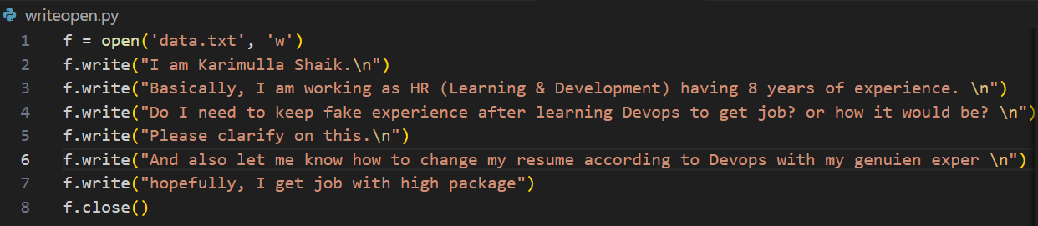

4. Read from a File

We used open in read mode and file.read to read and print to display.

